Subject and Code: Industrial Training (315004)
Academic Year: 2026-27
Course Name: Information Technology Semester: Fifth

A Report ON
Industrial Training at
‘Rigel Infotech’

Sr. No | Roll No | Names of Students | Enrolment No | Seat No
1 | 11 | Sayam Kalpesh Mutha | 24112470011

Under the Guidance of
Guide's Name — Vaibhav Patel

Three Years Diploma Programme in Engineering & Technology of Maharashtra
State Board of Technical Education, Mumbai (Autonomous)


MAHARASHTRA STATE BOARD OF TECHNICAL EDUCATION, MUMBAI

CERTIFICATE

This is to certify that Mr. Sayam Kalpesh Mutha, Roll No: 11 of Fifth Semester of Third Year Diploma in Information Technology at ST. JOHN COLLEGE OF ENGINEERING & MANAGEMENT has successfully completed the 12 weeks Internship of ITR (315004) in the Academic Year 2026-2027 as prescribed in the MSBTE prescribed curriculum of K Scheme, undergoing training at Rigel Infotech.

Place: Palghar Enrollment No: 24112470013
Date: __ / __ / 2026 Exam. Seat No: ______________

External Project Guide Head of the Department Principal
examiner
Index

SR No | Title | Page No.
1 | Acknowledgement | 4
2 | Abstract | 5
3 | Introduction | 6 – 7
4 | Internship Work | 8 – 10
5 | Project Worked On | 11 - 13
6 | Tools and Technologies Used | 14 – 15
7 | Project Development Stages | 16 – 18
8 | Project Screenshots | 19 - 25
9 | Future Scope | 26
10 | Conclusion | 27

Acknowledgement
I am sincerely thankful for the valuable learning experience I gained during my Industrial Training at Rigel Infotech. This internship gave me the opportunity to move beyond classroom concepts and build a real, full-stack web application from the ground up, from initial planning through to a live, deployed product. I would like to express my gratitude to the entire team at Rigel Infotech for structuring this internship programme and giving me the freedom to take on an ambitious real-world project: a complete e-commerce, billing, and business-management platform for my family's business, Hira Agro Industry. During this period, I learned and applied the MERN stack (MongoDB, Express.js, React, and Node.js) along with Tailwind CSS, JWT-based authentication, and modern deployment practices. I am especially grateful for the guidance that helped me understand both frontend and backend development, database design, authentication and role-based access control, RESTful API design, and the practical realities of deploying and securing a live web application. Working through real production issues — from a subtle CSS bug that silently broke spacing across the entire site, to CORS errors, environment-variable misconfiguration, and a GitHub permissions block during deployment — taught me more about real-world debugging than any single tutorial could. My sincere thanks also go to my family, whose actual business — Hira Agro Industry, and the four related family businesses of Vishakha Kalpesh Mutha, Hiraben Dilip Mutha, Vishakha Agro, and Vishakha Rice Mill — became the real foundation for this project. Being able to build software for a business I understand personally, using real GST invoice formats, real product data, and real operational needs, made this project far more meaningful than a generic assignment. Finally, I am thankful to Rigel Infotech for this opportunity to learn, build, and grow. This internship strengthened my foundation in full-stack web development and gave me the confidence to plan, build, debug, and ship a genuinely production-ready application.

Abstract
This report presents a detailed overview of my 12-week Industrial Training at Rigel Infotech and the practical knowledge I gained in full-stack web development using the MERN stack. During the internship, I learned and applied MongoDB, Express.js, React (with Vite), Node.js, Tailwind CSS v4, JWT authentication, and Framer Motion to design, build, test, and deploy a complete production web application. The main project developed during the internship was the Hira Agro Industry platform — a full-stack e-commerce, billing, and business-management system for a real rice-milling business, later expanded into a multi-tenant platform serving five related family businesses from a single shared codebase. The platform includes a public product catalogue, role-based Admin and Manager dashboards, real stock and sales tracking, a GST Tax Invoice generator with automatic CGST/SGST/IGST calculation matching the business's real letterhead, a simpler Bill of Supply format for non-GST-registered sister businesses, a Super Admin view aggregating all five businesses, and a labour attendance and salary/advance tracking system. The frontend was built with React (Vite) and Tailwind CSS, using a shared design-system of reusable components (Button, Card, SectionHeading) to keep styling consistent across every page. The backend was built with Node.js and Express, using JWT for authentication and role-based middleware to enforce access control at the API level, not just in the UI. MongoDB (via MongoDB Atlas) was used to store products, stock logs, sales, invoices, companies, labourers, attendance records, and payment entries, with a company-scoped data model supporting multiple businesses from one codebase. Throughout the project I gained practical experience in requirement analysis, UI/UX design, REST API design, authentication and authorization, database schema design, debugging real production bugs (including a CSS cascade-layer issue and several deployment-configuration issues), security hardening, and deployment to Vercel and Render. This internship improved my technical knowledge and developed my problem-solving, debugging, and time-management skills. Building Hira Agro Industry gave me practical, end-to-end experience in taking a real business's operational needs and turning them into a live, secure, role-based web application.

Introduction
Introduction of Rigel Infotech
Rigel Infotech is the organisation through which I undertook my Industrial Training, as part of a structured internship programme (Batch 2025-26) that combines guided learning with a real, self-directed final project. The programme includes orientation sessions, a maintained log book of internship activities, and a final project development phase, of which this report is the outcome.
The Problem
Many small and family-run businesses, including agricultural suppliers like rice mills, still operate largely offline. Product catalogues, stock levels, sales, and accounting are tracked on paper, and GST-compliant billing is handwritten using pre-printed bill books. This makes it difficult to track business performance at a glance, slows down day-to-day operations, and gives the business no online presence for customers, wholesalers, or exporters to discover it. This challenge is not limited to a single business — my family operates five related businesses (Hira Agro Industry, Vishakha Kalpesh Mutha, Hiraben Dilip Mutha, Vishakha Agro, and Vishakha Rice Mill), all facing the same operational gap.
The Solution — Hira Agro Industry Platform
To address this, I developed a full-stack web platform, built around Hira Agro Industry (a rice mill supplying Basmati, Sona Masuri, and Sella rice varieties to wholesalers, retailers, and exporters) and later expanded to support all five family businesses from a single shared codebase. The platform provides a public-facing product catalogue with live rates and stock status, secure role-based Admin and Manager dashboards, real stock and sales tracking, and a genuine GST Tax Invoice generator that matches the business's real physical letterhead — including automatic CGST/SGST/IGST calculation based on whether the buyer is in Maharashtra or another state. For the four sister businesses, which are not GST-registered in the same way, a simpler Bill of Supply format was built to match their existing paper bill books exactly. The platform also includes a Super Admin role that can view and switch between all five businesses, and a labour attendance and salary/advance tracking system to manage mill workers' daily attendance and payments. The frontend was built with React (Vite) and Tailwind CSS v4, following a reusable component-based design system. The backend was built with Node.js and Express, using JWT-based authentication with role-based access control enforced on the server, not just hidden in the UI. MongoDB Atlas was used as the database, and the finished application was deployed live using Vercel (frontend) and Render (backend). The project gave me hands-on experience with the complete lifecycle of a real web application: requirements gathering from an actual business owner, UI/UX design, frontend and backend development, authentication and security, database design, debugging real production issues, and deployment — the full scope of modern full-stack development.

Internship Work
Timeline Summary:
The 12-week Industrial Training at Rigel Infotech gave me practical, hands-on experience in full-stack web development using the MERN stack. Over the course of the internship, I planned, designed, built, tested, secured, and deployed a real production web application for my family's business, Hira Agro Industry, which later expanded into a multi-business platform serving five related businesses.

Week 1(Intro to Web Dev):

I started the internship by understanding the fundamental architecture of how websites work on the internet. This involved learning the basic structural parts of a web page and how browsers read code to display content. During this week, I familiarized myself with the development environment and the initial setup required to start building. Grasping these core concepts was a crucial first step before writing any actual code, ensuring I had a strong mental model for what would eventually become the Hira Agro platform.

Week 2(Semantic Tags & CSS):

I focused on structuring web content meaningfully by learning to use semantic HTML tags properly. This ensures the website is organized, accessible, and easily readable by browsers. I also dived deep into styling by learning the CSS box model to understand margins, borders, and padding. Furthermore, I began to use Flexbox for styling, which became my primary tool for creating responsive, clean layouts that would adapt to different screen sizes for the project's dashboards.

Week 3(Media & Web Forms):

I transitioned from static design to logic by revising fundamental JavaScript basics. This included going over variables, loops, and functions to ensure my programming core was absolutely solid before moving forward. The major milestone this week was successfully connecting this JavaScript logic to the HTML page. This step was vital because it transformed the static designs into a platform capable of executing basic logic and responding to user actions.

Week 4 (JavaScript Revision):
I implemented authentication using JSON Web Tokens (JWT), with two roles: Admin and Manager. I built role-based middleware on the backend so that access control was enforced at the API level, not just by hiding buttons in the UI. I specifically tested this by attempting to access admin-only routes while logged in as a manager, and confirmed the backend correctly blocked unauthorised access.

Week 5 (Dynamic Elements):

I started working directly with forms and dynamic elements to capture and process user data effectively. By extensively practicing DOM-based page changes, I learned how to update the website's interface in real-time. This meant I could display error messages, update numbers, or change visual elements based on user input instantly without requiring the entire web page to refresh, making the platform feel much faster

Week 6 (JS Project Work):

To solidify my learning before moving to advanced frameworks, I applied all these core concepts in a small project. This week was heavily focused on practicing problem-solving and code debugging. I learned how to read error logs in the console, trace bugs back to their source, and write cleaner, more reliable logic. This troubleshooting experience was crucial preparation before building the actual billing and accounting logic for Hira Agro.

Week 7 (Introduction to React):

I shifted gears into modern frontend development by understanding what React is primarily used for. I learned about its virtual DOM and why it is so effective for building fast, responsive single-page applications. I spent time setting up the modern toolchain and learning the basic React development workflow. This foundational knowledge was necessary to plan exactly how the complex Hira Agro multi-business dashboards would be structured.

Week 8 (JSX & Components):

I learned to write JSX syntax fluently, which allowed me to seamlessly blend HTML structures with JavaScript logic directly inside React files. The core focus was learning to build React components and truly understand component-based UI architecture. Instead of writing one massive page, I began thinking of the UI as distinct, independent blocks—like a navigation bar, a product card, or a billing table—that could be developed and tested separately.

Week 9 (Fragments & UI):

I focused on optimizing the application's structure by using React Fragments correctly to keep the DOM clean and avoid unnecessary HTML wrapper elements. The main goal of this week was to build reusable UI pieces. For example, by creating standard buttons and input fields that could be used across all 5 family business dashboards, I saved massive amounts of development time and ensured a consistent design throughout the entire platform.

Week 10 (Components & Props):
I learned to manage complex layouts by understanding component hierarchy deeply. I practiced how to safely pass data with props from parent components down to child components. This was the key to building dynamic UI elements. By mastering props, I could create a single "Invoice Card" template and dynamically pass different business names, amounts, and GST details into it, making the multi-tenant architecture possible.

Week 11 (State with useState):

I tackled the challenge of managing dynamic data within the application by learning to store changing values with the useState() hook. To truly understand how state triggers UI updates, I studied component re-rendering through practical projects, like a counter. This knowledge was immediately applied to the Hira Agro project to handle live shopping cart updates, real-time stock deductions, and toggling between different admin views.

Week 12 (Conditional UI):
I brought the platform to life by learning to handle user interactions seamlessly with events like clicks and form submissions. I mastered conditional rendering using && operators, ternary operators, and login status conditions. This was absolutely essential for implementing the project's role-based security, ensuring I could display sensitive accounting data or admin controls only when a verified manager was actively logged into the dashboard.

Project Worked On
After completing the initial learning and planning phase of my internship at Rigel Infotech, I applied the knowledge and skills gained by developing a real, production project titled Hira Agro Industry — A Multi-Business E-Commerce, Billing, and Management Platform.

Project Overview
Hira Agro Industry is a dynamic, full-stack web platform built to bring a real rice-milling business online — combining a public product catalogue, role-based staff dashboards, genuine GST-compliant billing, and multi-business management into a single system. The platform was later extended to serve five related family businesses from a single shared codebase, rather than being rebuilt separately for each one. The website was developed using React (Vite) and Tailwind CSS v4 for the frontend, Node.js and Express.js for the backend, and MongoDB (via MongoDB Atlas) for the database. JWT (JSON Web Tokens) was used for authentication, with role-based middleware enforced on the backend. Framer Motion was used for subtle, purposeful animation. The finished application was deployed using Vercel (frontend) and Render (backend).

Home Page
The Home Page is the public entry point of the site. It features a full-bleed hero section with the business's story ('Grain-perfect rice, milled with three generations of trust.'), a quality-standards section, a 'Why Hira Agro Industry' section with real business statistics (years running, tonnes processed per year, dealer network size, rice varieties offered), and a call-to-action section directing visitors to the product catalogue or contact page.

Products Page
The Products page displays the full rice catalogue as a filterable, searchable grid of cards, each showing the rice variety, rate per unit, description, and livestock status. Filtering by variety (Basmati, Sona Masuri, Sella, Kolam, IR64) and text search are both supported, with the product data pulled live from the database rather than hardcoded.

Contact Page
The Contact page displays the business's real contact details (phone numbers, email, address, operating hours) alongside a working contact form. Submitted messages are stored in the database and appear in an Admin-facing inquiries inbox, turning the contact form into a genuine lead-capture feature rather than a dead end.

Staff Login
A dedicated Staff Login page provides secure access for Admin, Manager, and Super Admin roles, with JWT-based session handling and role-based redirection after login.

Admin Dashboard
The Admin Dashboard is the central management interface, including sections for: an Overview (key statistics such as total products, revenue, active managers, and low-stock alerts), Products (add / edit / delete with photo upload), Managers (create and manage manager accounts scoped to the business), Stock Logs (a full history of stock changes), Sales (a full sales ledger with revenue totals), Invoices (GST Tax Invoice generation and history for Hira Agro Industry), Inquiries (contact-form submissions), and Labour (attendance and payment tracking, described below).

Manager Dashboard
The Manager Dashboard is a scoped-down version of the admin interface, allowing a manager to update stock, record sales (accounting), and manage labour attendance for their assigned business, without access to business-wide administrative controls such as managing other manager accounts.

GST Invoice System
For Hira Agro Industry, which is GST-registered, the platform generates a full GST Tax Invoice matching the business's real printed letterhead exactly — company details, buyer details, a line-items table with HSN codes and GST percentages, automatic CGST + SGST or IGST calculation (depending on whether the transaction is intra-state or inter-state), round-off handling, an auto-generated amount-in-words field, and bank details for payment. Invoices can be listed, searched, and printed.

Bill of Supply System
For the four sister businesses — Vishakha Kalpesh Mutha, Hiraben Dilip Mutha, Vishakha Agro, and Vishakha Rice Mill — which are not GST-registered in the same way, a simpler Bill of Supply format was built, matching each business's real paper 'Cash / Credit Memo' bill book exactly, including each business's own PAN number and bank details.

Multi-Business (Multi-Tenant) Architecture
Rather than duplicating the codebase for each of the five businesses, a single Company data model holds each business's own details (name, proprietor, address, billing format, bank details), and every business-data record (products, stock, sales, invoices) is scoped to a company. This means a bug fix or design update made once applies automatically to every business, and a Super Admin role can view or switch between all five businesses from one account.

Labour Attendance & Salary System
A dedicated Labour section allows Admin and Manager users to add mill workers, mark daily attendance (present, absent, or half-day), and record salary payments alongside advances or bonuses given outside of regular pay. The system automatically calculates monthly salary based on attendance and produces a running ledger per worker.

Tools and Technologies Used

Visual Studio Code (VS Code)
Visual Studio Code was the primary code editor used throughout the project, for both the React frontend and the Node.js/Express backend. Features such as syntax highlighting, IntelliSense, integrated terminal, and Git integration supported efficient day-to-day development.

MongoDB Atlas
MongoDB Atlas provided a free-tier cloud-hosted MongoDB cluster used as the application's database in both development and production, storing users, products, stock logs, sales, invoices, companies, labourers, attendance records, and payment entries.

Node.js and Express.js
Node.js and the Express.js framework were used to build the backend REST API, handling authentication, role-based authorization, and all CRUD operations for the platform's data models.

React (with Vite)
React, bootstrapped with Vite, was used to build the frontend single-page application, structured around reusable components and React Router for client-side navigation.

Tailwind CSS v4
Tailwind CSS v4 was used for styling, with a custom design-token theme (colours, fonts, spacing) defined via the '@theme' directive in index.css.

JWT (JSON Web Tokens)
JWT was used to implement stateless authentication, with role information embedded in the token and verified by backend middleware on every protected request.

Framer Motion
Framer Motion was used to add subtle, purposeful animation — scroll-reveal effects, staggered list animations, and smooth transitions — without compromising performance or usability.

Git and GitHub
Git was used for version control throughout the project, with the repository hosted on GitHub, connected directly to both Vercel and Render for continuous deployment on every push to the main branch.

Vercel
Vercel was used to deploy the React frontend, with environment variables used to configure the production API base URL.

Render
Render was used to deploy the Node.js/Express backend as a web service, connected to the MongoDB Atlas database via environment variables.

Browser Developer Tools
Browser Developer Tools (Console and Network tabs) were used extensively to diagnose real issues during both local development and after deployment, including CORS errors, failed API requests, and JavaScript errors.

Google Search Console
Google Search Console was used to verify site ownership, submit the sitemap, and request indexing for the live site, as part of basic SEO setup.

Project Development Stages

1. Requirement Analysis
The first stage was identifying the real operational needs of Hira Agro Industry and its sister businesses: an online product catalogue, role-based staff access, real stock and sales tracking, GST-compliant billing matching existing paper formats, and a way to manage five related businesses without duplicating effort.

2. Project Planning
The project was divided into clear modules — public site, authentication, Admin/Manager dashboards, GST invoicing, multi-business architecture, and labour management — with the MERN stack selected as the technology foundation.

3. User Interface Design
A forest-green, gold, and cream colour system was chosen to reflect the agricultural business identity. A reusable component-based design system (shared Button, Card, and SectionHeading components) was built so visual consistency could be maintained and updated in one place across the entire application.

4. Frontend Development
React (Vite) and Tailwind CSS were used to build the visible, interactive parts of the site, including the public pages and both dashboards, with Framer Motion used for subtle scroll and interaction animation.

5. Database Design
A MongoDB schema was designed with collections for Users, Products, StockLogs, Sales, Invoices, BillOfSupply records, Companies, Labourers, Attendance, LabourPayments, and Contact messages, with company-scoping applied across every business-data collection.

6. Backend Development
Node.js and Express.js were used to build the REST API, handling authentication, role-based authorization, and CRUD operations for every data model, with all business logic (such as GST tax calculation) implemented server-side.

7. Authentication & Role-Based Access
JWT-based authentication was implemented with Admin, Manager, and Super Admin roles, with access control enforced by backend middleware and explicitly verified through direct testing rather than assumed from the UI alone.

8. Home & Public Page Development
The Home, Products, and Contact pages were built to present the business publicly, with live product data, filtering and search, and a working, database-backed contact form.

9. Admin & Manager Dashboard Development
Role-scoped dashboards were built for Admin and Manager users, covering products, stock, sales, managers, inquiries, and invoices.

10. GST Invoice Development
A GST Tax Invoice generator was built for Hira Agro Industry, matching the business's real letterhead, with automatic CGST/SGST/IGST calculation based on Indian GST rules for intra-state versus inter-state sales.

11. Multi-Tenant Architecture Development
The application was restructured to support five businesses from one shared codebase, using a Company model and company-scoped data, rather than duplicating the project.

12. Bill of Supply Development
A simpler, non-GST Bill of Supply invoice format was built for the four sister businesses, matching their existing paper bill books.

13. Labour Attendance Development
Attendance marking, monthly salary calculation, and advance/bonus payment tracking were built for mill workers, scoped per business.

14. Module Integration
All modules were connected end-to-end — frontend pages, backend API routes, and the MongoDB database — with every feature tested using real data rather than placeholders.

15. Testing and Debugging
The complete platform was tested across every role and feature, including a deliberate security test of role-based access restrictions, and real bugs (detailed in the Testing and Debugging section) were diagnosed and fixed.

16. Security Hardening
An exposed credential was identified and rotated, and role-based access restrictions were re-verified under direct testing before deployment.

17. Deployment
The frontend was deployed to Vercel and the backend to Render, connected to MongoDB Atlas, with real production issues (CORS, environment variables, SPA routing) diagnosed and resolved.

18. SEO Setup
Google Search Console was configured, ownership was verified, and a sitemap.xml bug (pointing to localhost instead of the live domain) was found and fixed.

19. Final Review and Documentation
All pages and modules were reviewed for consistency and correctness, and this report was prepared summarising the requirement analysis, design, development, testing, and deployment of the completed platform.

Project Screenshots

The following pages should be captured from the live deployed application and inserted here before final submission:



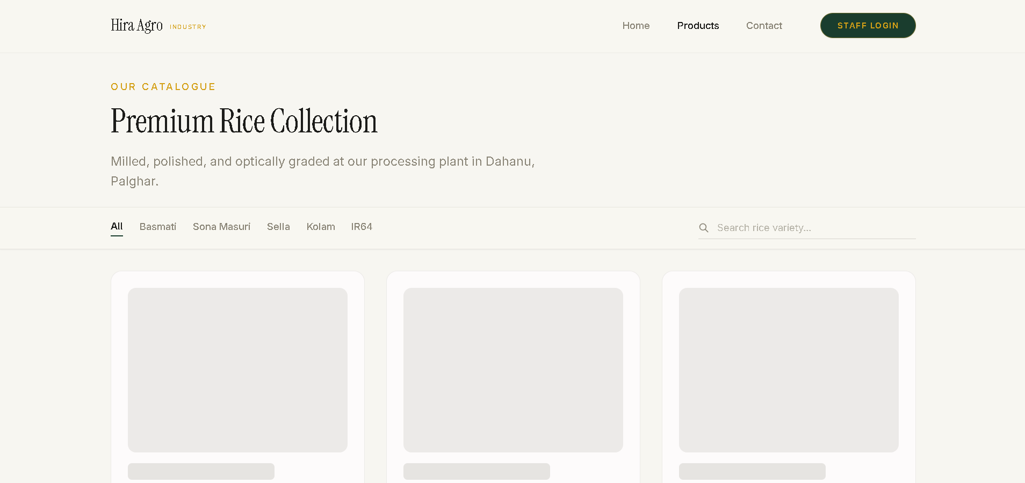

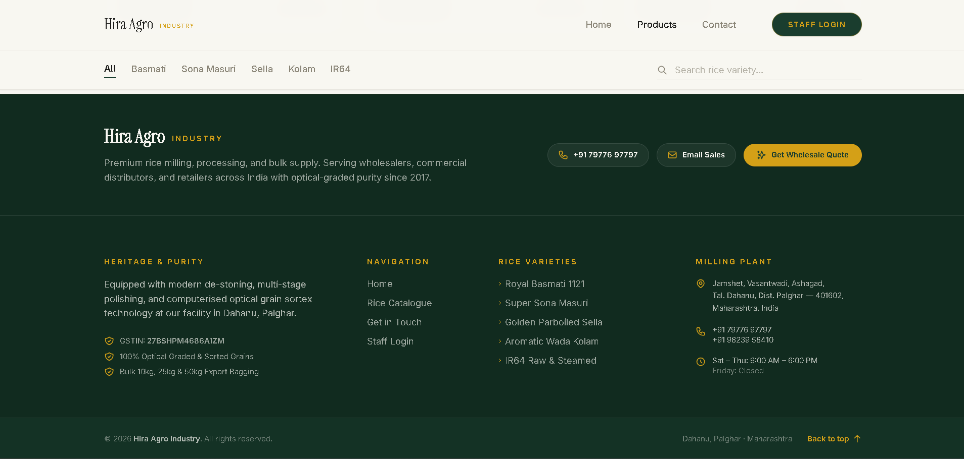

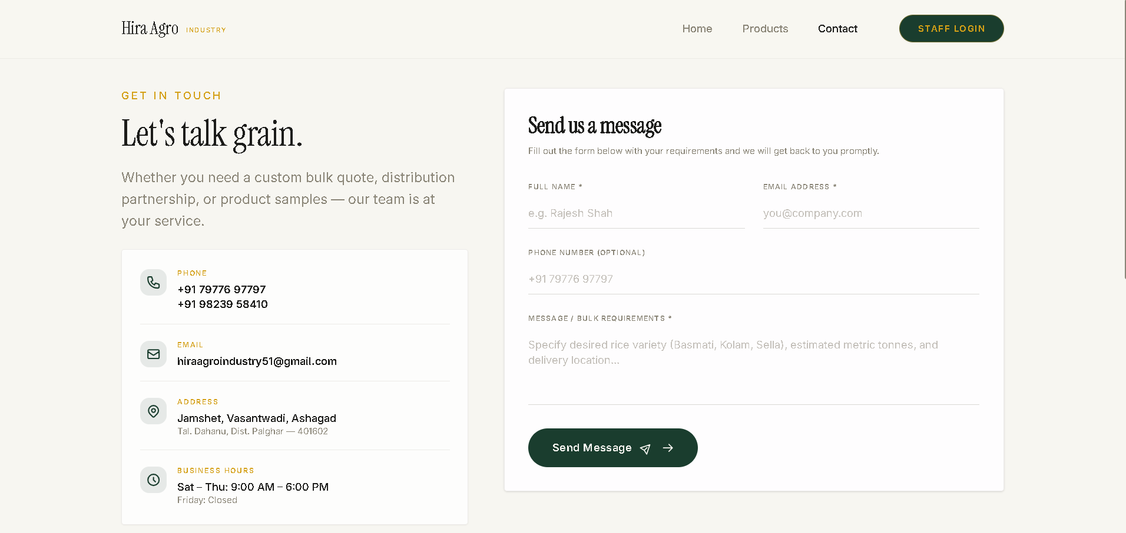

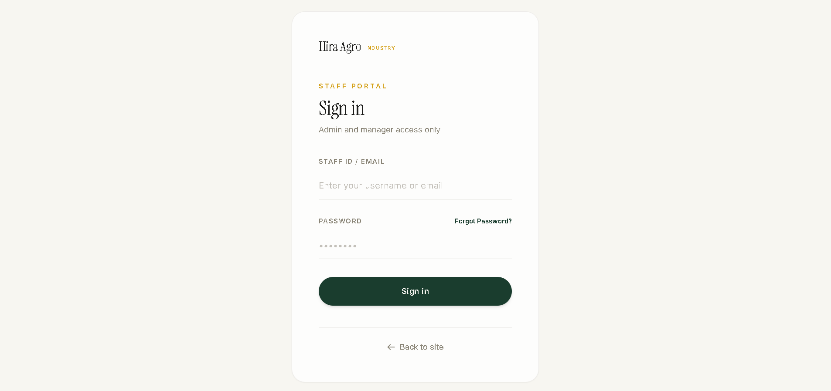

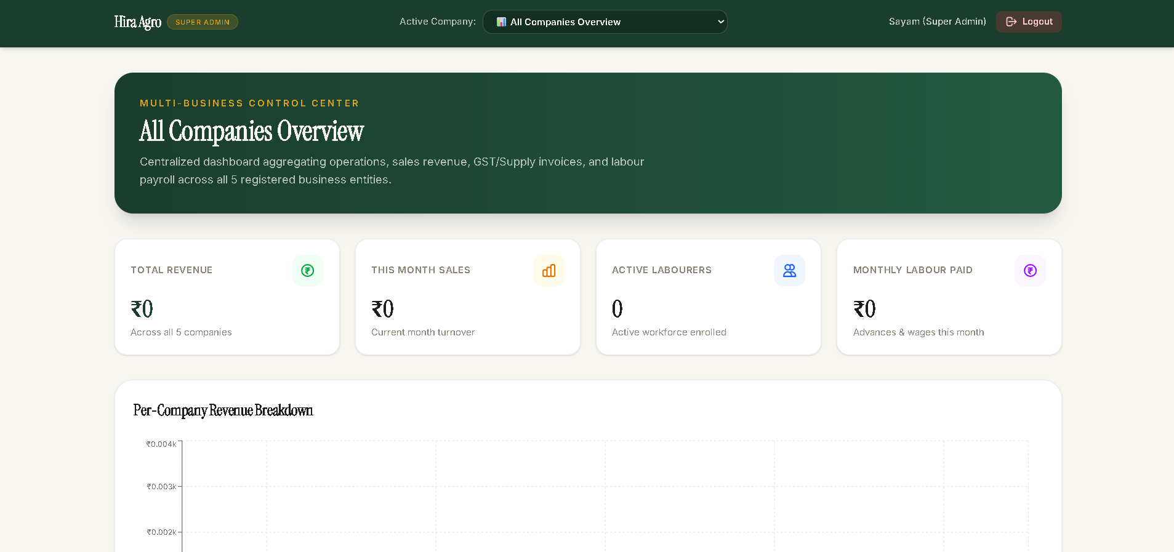

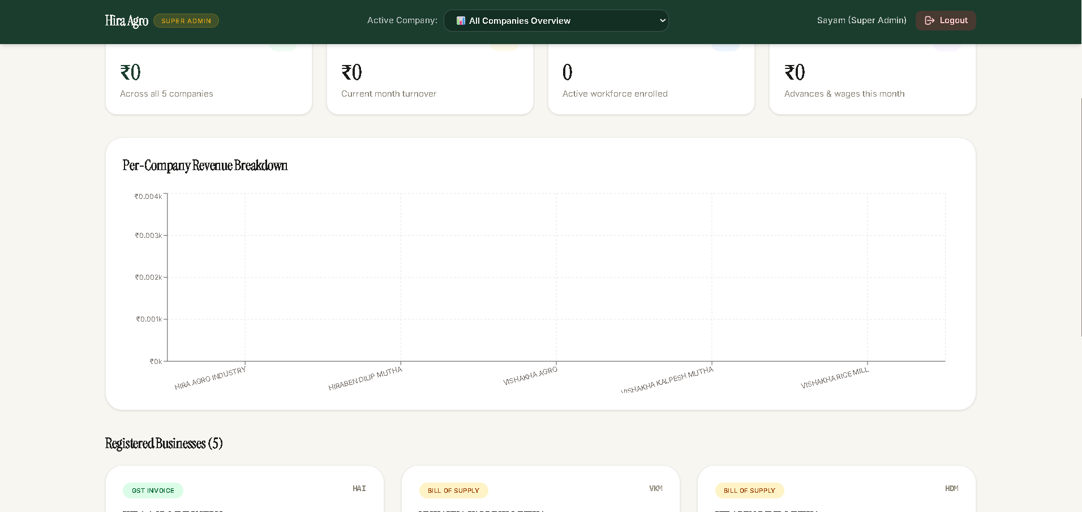

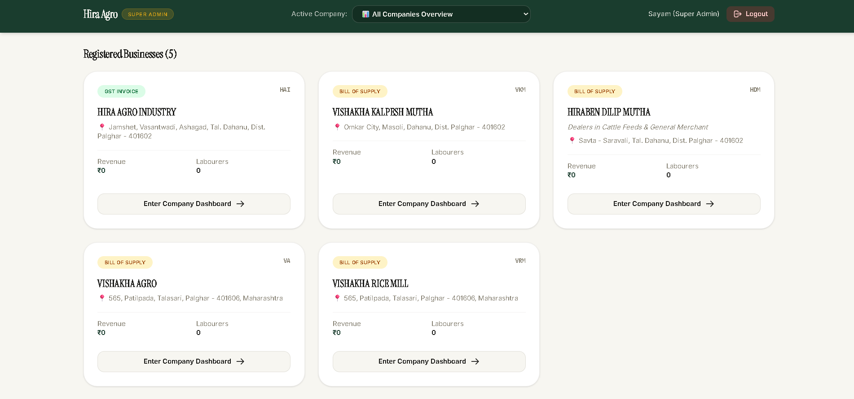

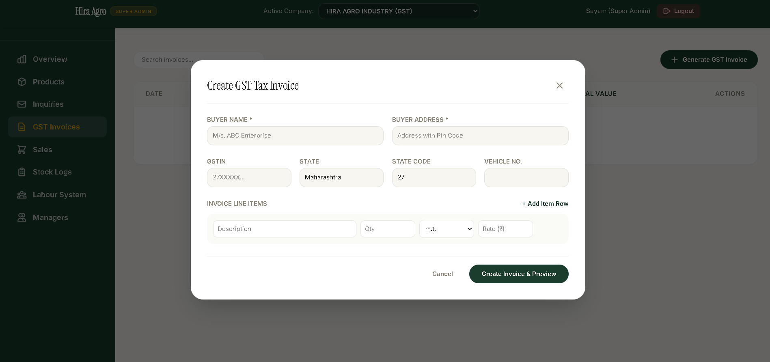

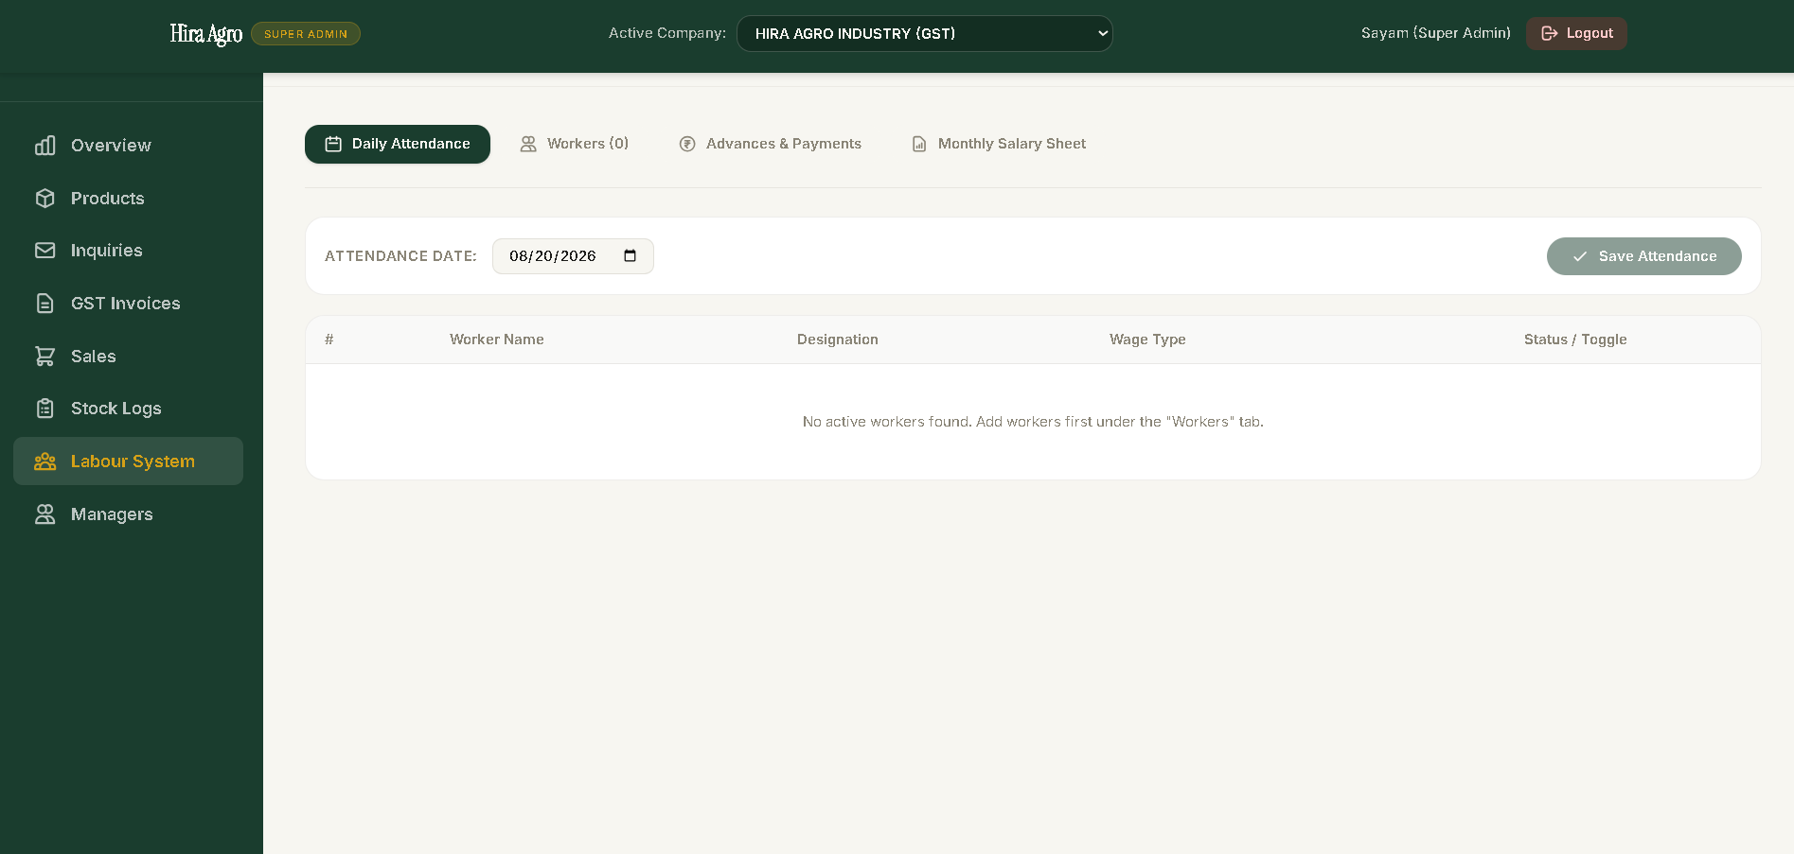

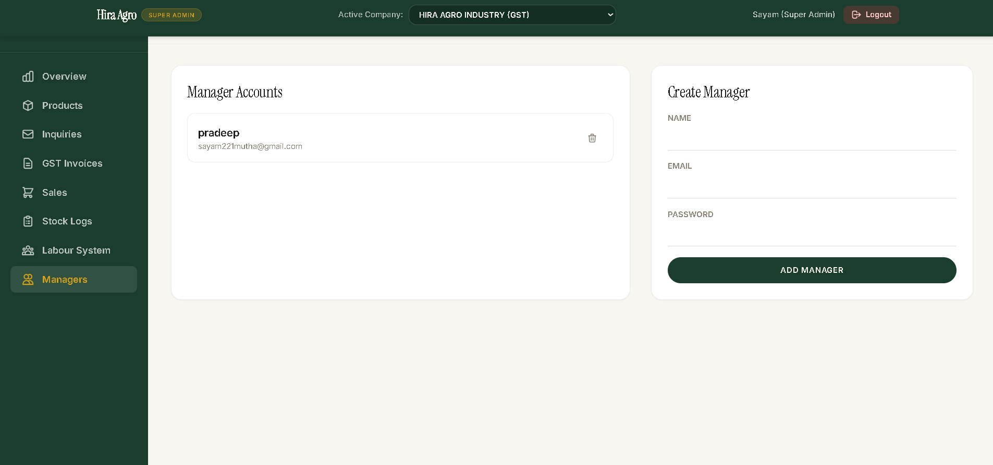

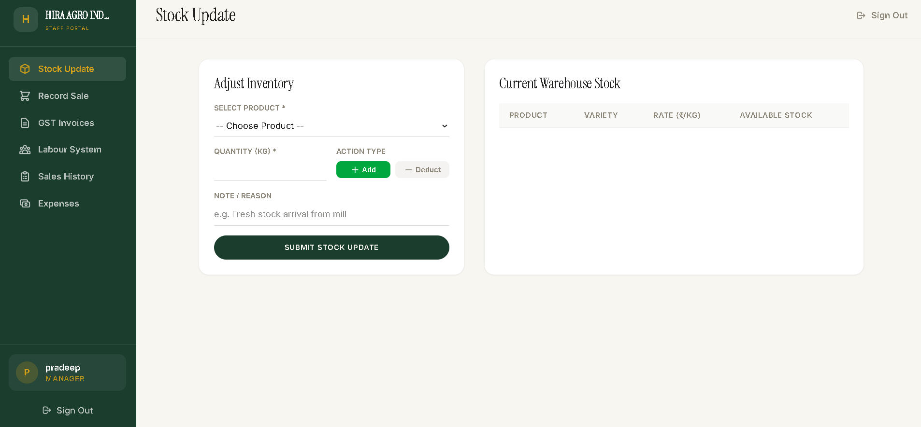

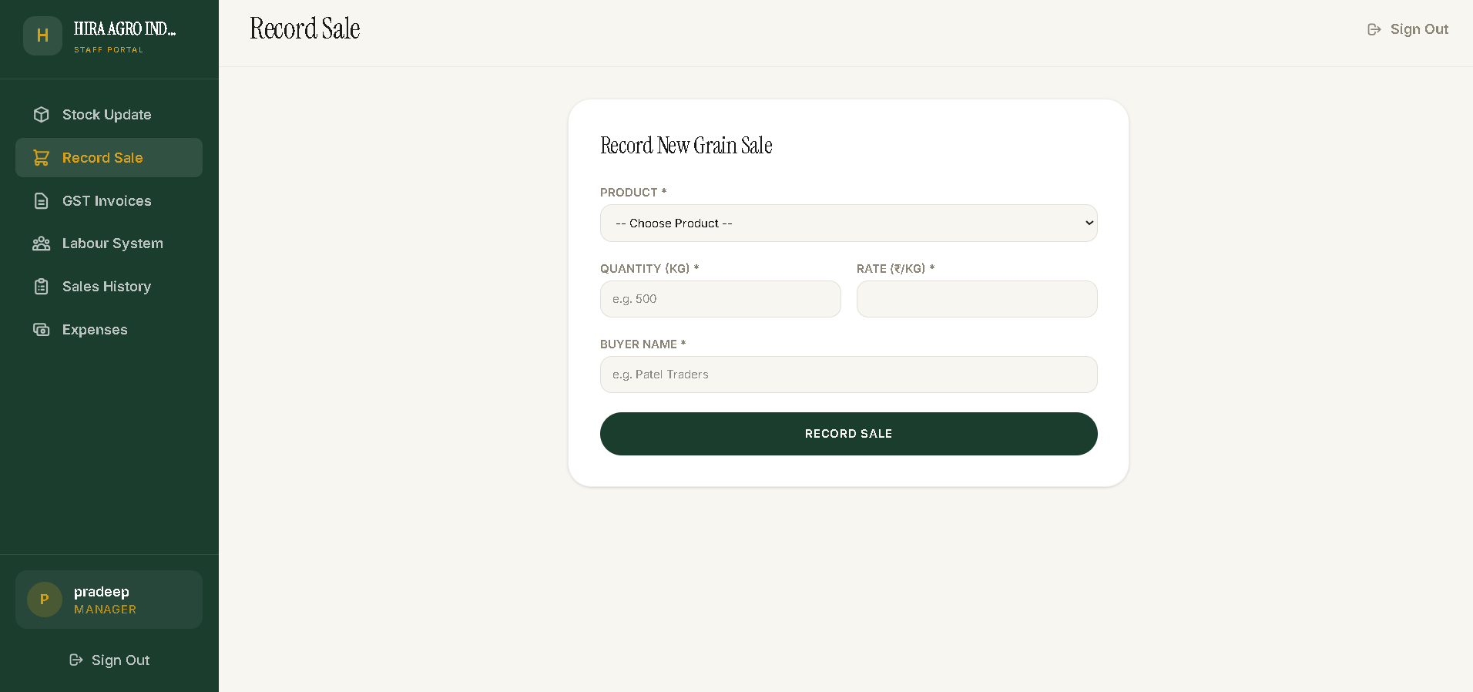
Future Scope
Hira Agro Industry can be extended further with additional features to make the platform more complete and useful for daily business operations:
- Online payment integration (UPI, cards, net banking) to support direct online orders from wholesalers and retailers.
- SMS or email notifications for low-stock alerts, new inquiries, and completed sales.
- Advanced sales analytics and forecasting, building on the existing revenue chart to help predict demand across seasons.
- A dedicated mobile application for Admin and Manager use, so stock and sales can be updated directly from the mill floor.
- Automated GST return-ready export reports, generated directly from recorded invoices.
- Expansion of the multi-tenant architecture to onboard additional businesses beyond the current five, with self-service company setup.
- Two-factor authentication and further security hardening for Admin and Super Admin accounts.
- Automated database backups and monitoring/alerting for production uptime.
With these additions, Hira Agro Industry can grow from a working internship project into a genuinely long-term operational tool for the family business.
Conclusion

The Hira Agro Industry project was successfully developed as a responsive, secure, database-driven, full-stack web platform. What began as a single business's product catalogue and staff dashboard grew, over the course of the internship, into a multi-tenant platform serving five related family businesses, with genuine GST-compliant billing, role-based security, and a labour management system. The platform was built using React (Vite) and Tailwind CSS v4 for the frontend, Node.js and Express.js for the backend, and MongoDB Atlas for the database, with JWT-based authentication enforced through backend middleware rather than relying on the UI alone. The finished application was deployed live using Vercel and Render, and configured for basic SEO through Google Search Console. During development, I encountered and resolved several real technical challenges: a subtle CSS Cascade Layers bug that silently broke spacing across the entire site, a hardcoded API URL that broke the application in production, a CORS misconfiguration, a GitHub permissions block during deployment, and an exposed credential that needed to be rotated immediately rather than just hidden. Solving each of these problems by reading actual source code and reasoning from first principles, rather than guessing, was the most valuable part of the internship. This project gave me genuine, end-to-end experience in full-stack web development: requirement analysis from a real business, UI/UX design, frontend and backend development, authentication and authorization, database schema design, debugging real production issues, security hardening, and deployment. It also strengthened my problem-solving ability, attention to detail, and confidence in shipping and maintaining a real, live application — skills that will directly support my continued growth in software development. Overall, Hira Agro Industry demonstrates how a real family business's day-to-day operational needs — product sales, stock tracking, GST billing, and labour management — can be brought together into one secure, modern, and genuinely useful digital platform.

